**Exercise 2: Error Handling**

**Scenario 1:** Handle exceptions during fund transfers between accounts.

**Question:** Write a stored procedure **SafeTransferFunds** that transfers funds between two accounts. Ensure that if any error occurs (e.g., insufficient funds), an appropriate error message is logged and the transaction is rolled back.

CREATE OR REPLACE PROCEDURE SafeTransferFunds (

p_from_account IN NUMBER,

p_to_account IN NUMBER,

p_amount IN NUMBER

)

AS

v_balance NUMBER;

insufficient EXCEPTION; -- fixed spelling

BEGIN

-- Step 1: Lock and check source account balance

SELECT Balance INTO v_balance

FROM Accounts

WHERE AccountID = p_from_account

FOR UPDATE;

-- Step 2: Check for sufficient balance

IF v_balance < p_amount THEN

RAISE insufficient;

END IF;

-- Step 3: Deduct from source account

UPDATE Accounts

SET Balance = Balance - p_amount

WHERE AccountID = p_from_account;

-- Step 4: Add to destination account

UPDATE Accounts

SET Balance = Balance + p_amount

WHERE AccountID = p_to_account;

-- Step 5: Commit the transaction

COMMIT;

DBMS_OUTPUT.PUT_LINE('Transfer of ' || p_amount || ' from Account ' ||

p_from_account || ' to Account ' || p_to_account || ' successful.');

EXCEPTION

WHEN insufficient THEN

ROLLBACK;

DBMS_OUTPUT.PUT_LINE('Insufficient funds');

WHEN OTHERS THEN

ROLLBACK;

DBMS_OUTPUT.PUT_LINE('Error during fund transfer: ' || SQLERRM);

END;

/

BEGIN

SafeTransferFunds(1, 2, 2000);

END;

/

Output:-

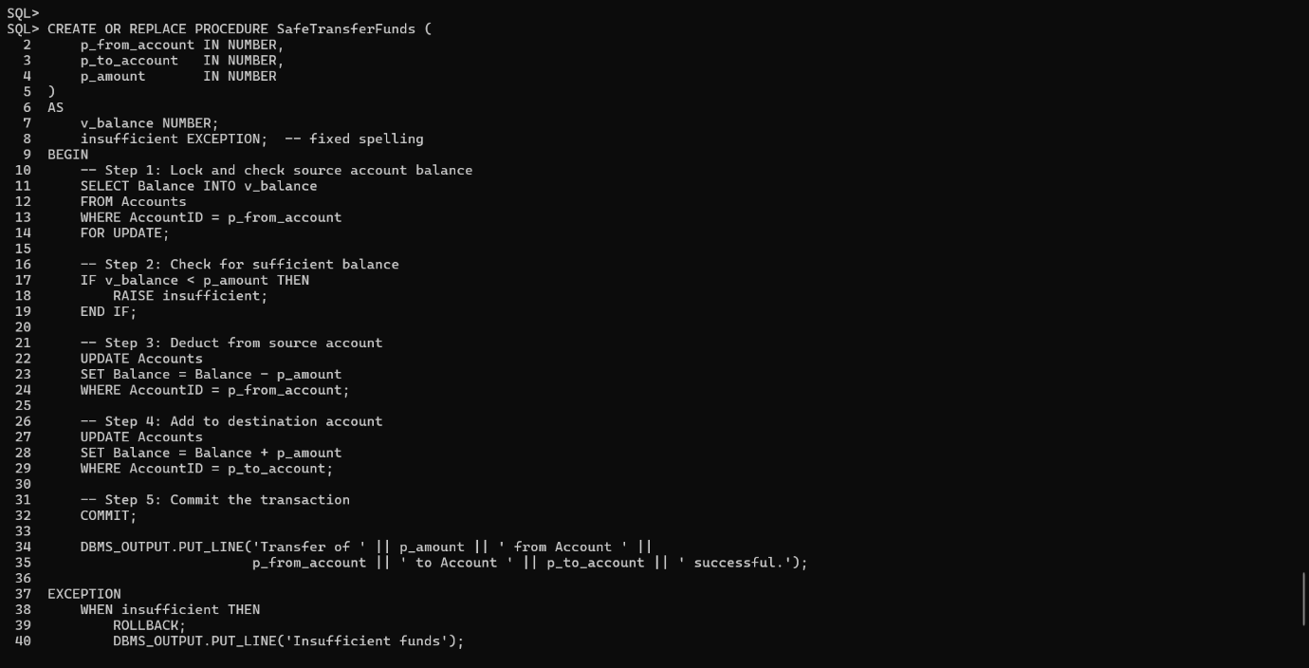

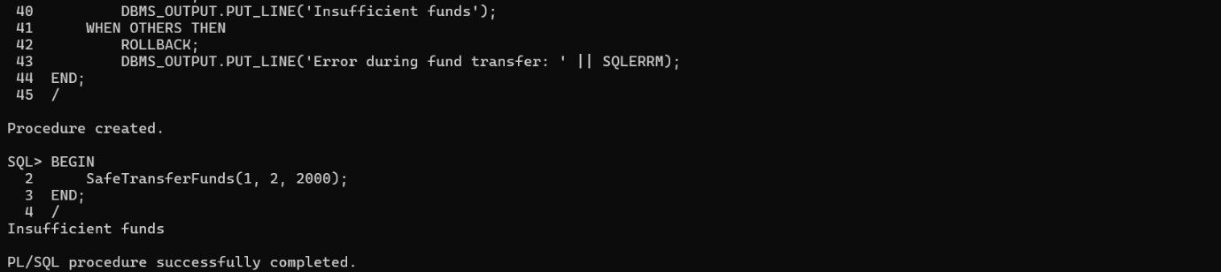

**Scenario 2:** Manage errors when updating employee salaries.

**Question:** Write a stored procedure **UpdateSalary** that increases the salary of an employee by a given percentage. If the employee ID does not exist, handle the exception and log an error message.

CREATE OR REPLACE PROCEDURE GetCustomerName (

p_customer_id IN NUMBER

)

AS

v_name Customers.Name%TYPE;

BEGIN

-- Try to fetch the name for the given CustomerID

SELECT Name INTO v_name

FROM Customers

WHERE CustomerID = p_customer_id;

DBMS_OUTPUT.PUT_LINE('Customer Name: ' || v_name);

EXCEPTION

WHEN NO_DATA_FOUND THEN

DBMS_OUTPUT.PUT_LINE('No customer found with ID: ' || p_customer_id);

WHEN OTHERS THEN

DBMS_OUTPUT.PUT_LINE('Unexpected error: ' || SQLERRM);

END;

/

Begin

GetCustomerName(100);

End;

/

**Output :-**

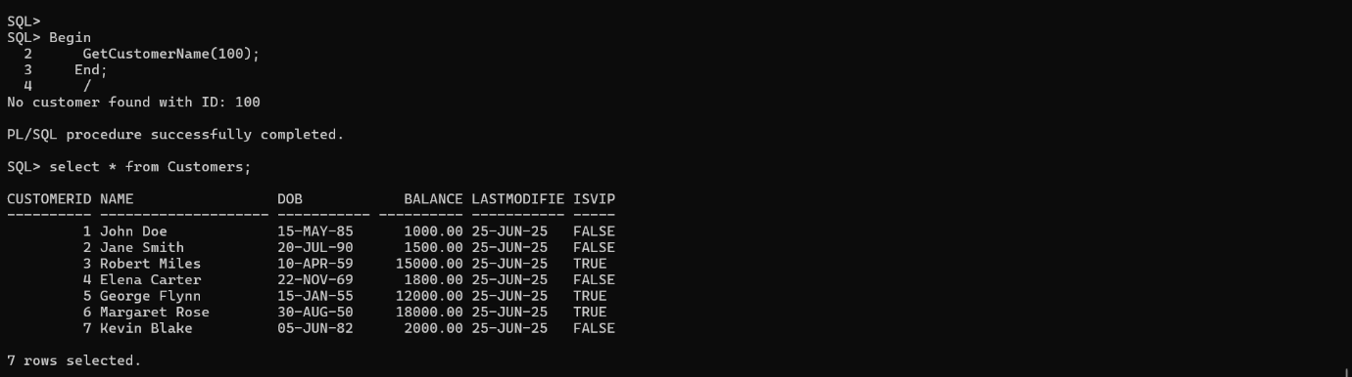

**Scenario 3:** Ensure data integrity when adding a new customer.

**Question:** Write a stored procedure **AddNewCustomer** that inserts a new customer into the Customers table. If a customer with the same ID already exists, handle the exception by logging an error and preventing the insertion.

CREATE OR REPLACE PROCEDURE AddNewCustomer (

p_customer_id IN Customers.CustomerID%TYPE,

p_name IN Customers.Name%TYPE,

p_dob IN Customers.DOB%TYPE,

p_balance IN Customers.Balance%TYPE

)

AS

dup_customer EXCEPTION;

PRAGMA EXCEPTION_INIT(dup_customer, -00001); -- ORA-00001: unique constraint violated

BEGIN

INSERT INTO Customers (CustomerID, Name, DOB, Balance, LastModified)

VALUES (p_customer_id, p_name, p_dob, p_balance, SYSDATE);

DBMS_OUTPUT.PUT_LINE('Customer inserted successfully: ' || p_name);

EXCEPTION

WHEN dup_customer THEN

DBMS_OUTPUT.PUT_LINE('Error: Customer ID ' || p_customer_id || ' already exists. Insertion aborted.');

WHEN OTHERS THEN

DBMS_OUTPUT.PUT_LINE('Unexpected error: ' || SQLERRM);

END;

/

**Output :-**

